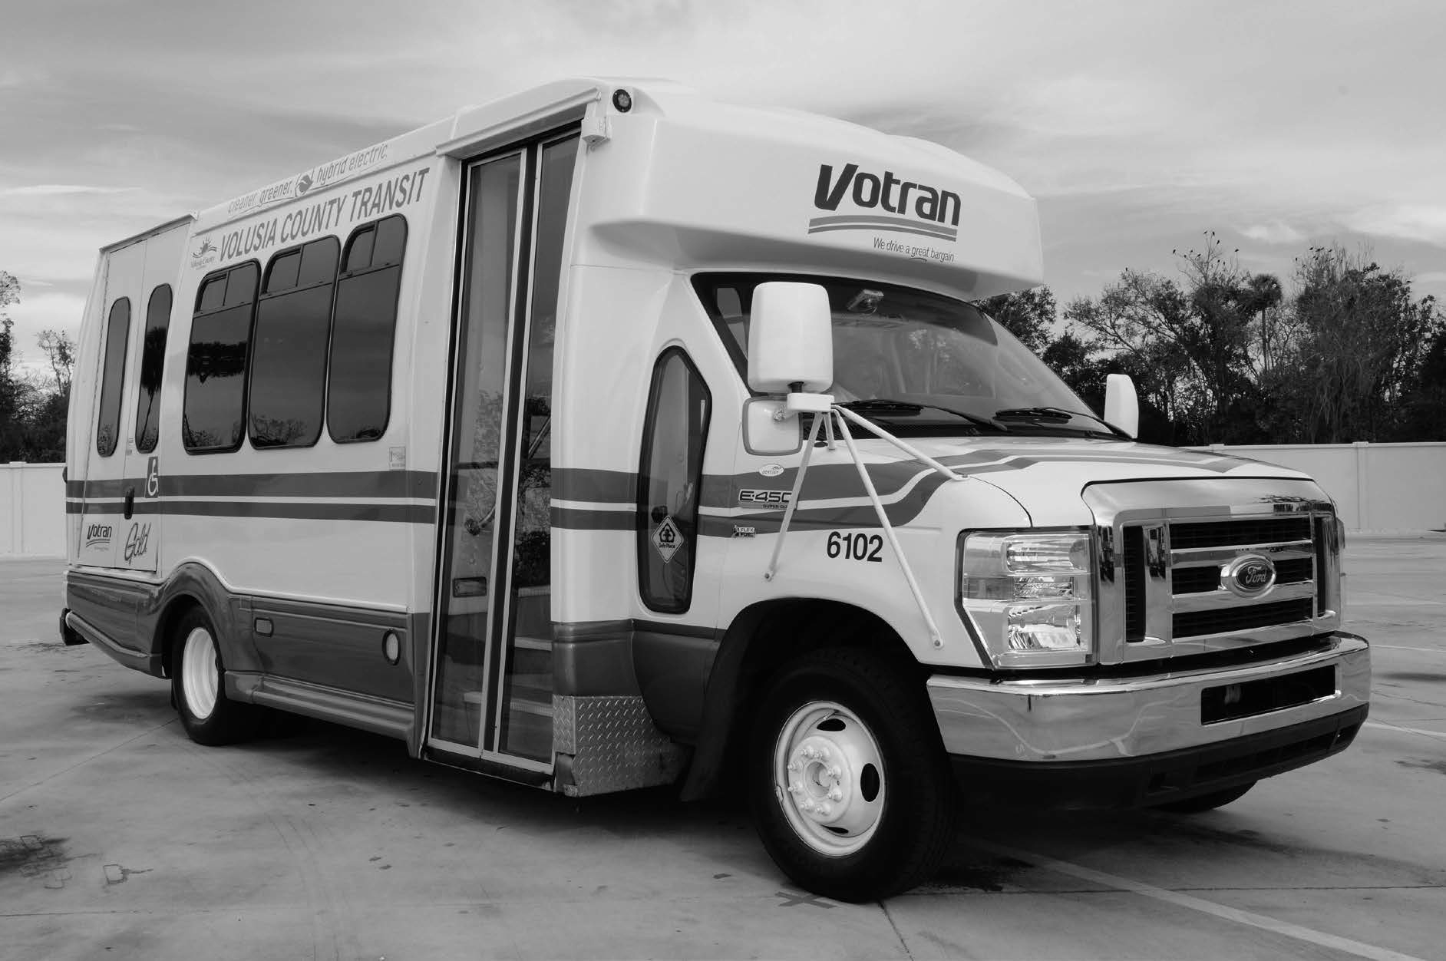
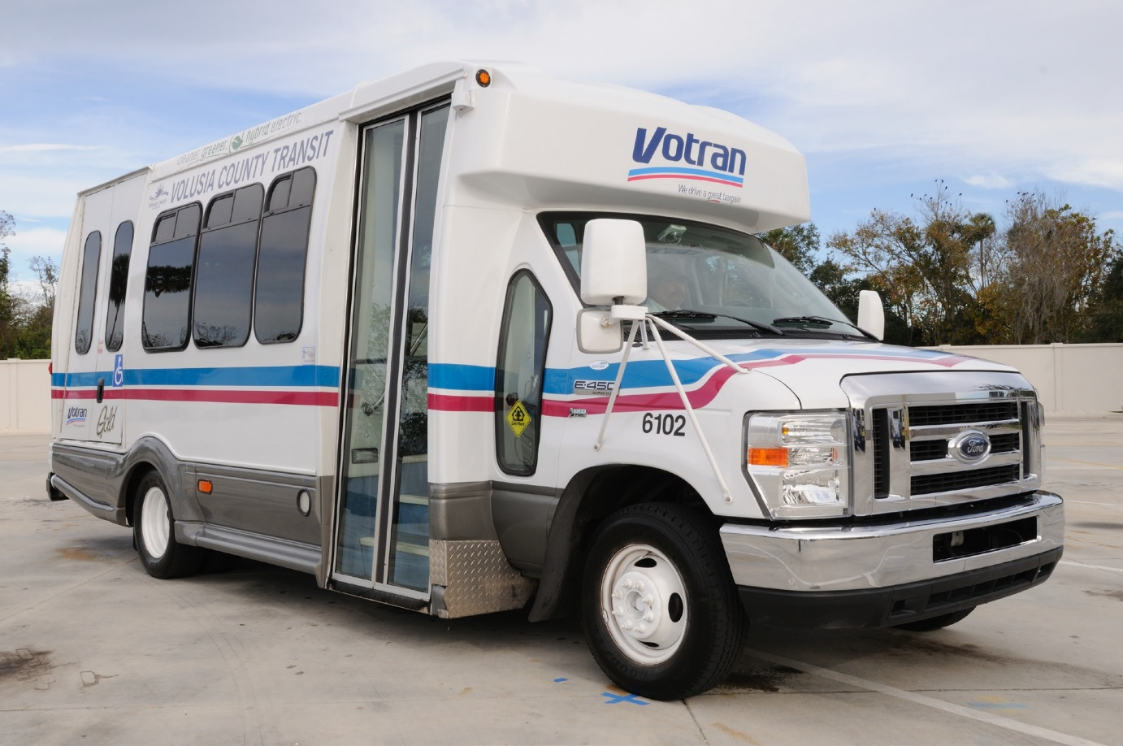



votran.org
JUNE 2023

Votran Gold Service Users Guide
Votran Gold Service Users Guide
A Service of Volusia County Government
A Service of Volusia County Government

Image: Votran vehicles utilized in the provision of Votran Gold service.
votran.org
March 2019

Votran Gold Service User’s Guide

Votran Gold Service Contact Information

Call Center for Reservations
East Volusia
(386) 322-5100
West Volusia
(386) 943-7050
Southeast Volusia
(386) 424-6810

Florida Relay Center
7-1-1

Email Comments
VotranCustomerService@volusia.org

Table of Contents
Table of Contents

Mission Statement 1
Introduction 2
Vo-Call User Guide 3
Votran Gold Service Overview 5
Groups Participating in Coordinating Votran Gold 6
Service Areas 7
Destinations 8
Service Times 10
Gold Service Eligibility 12
Visitors with Disabilities 14
Travel Assistance 15
Oxygen Transport 15
Package/Personal Belongings Policy – 2020 15
Age Requirements 18
Companions 18
Service Animals 19
Personal Care Attendants 19
Reserving Your Trip… 21
Contacting Reservations 21
Subscription Service 26
Best Times to Ride 26

Taking Your Trip 27
Fare Information 27
Drivers and Vehicles 28
Not Ready For Pick Up 30
Cancellation and No-Show Policy 31
No-Show 31
Same Day Cancellation 31
Advance Cancel 31
Rights and Responsibilities 35
Safety 35
Courtesy 36
Complaints 37
Service 38
Appropriate Behavior 39
Transportation During Emergencies 41
Customer Feedback. 43
Acknowledgement of Receipt Form 45
Notes 46
Votran Bus Service 48

Mission Statement
Mission Statement

Votran's mission is to identify and safely meet the mobility needs of Volusia County. This mission will be accomplished through a courteous, dependable, and environmentally sound team commitment to quality service.

Introduction
Introduction

Votran is a service of Volusia County Government, providing non- medical and non-emergency transportation within the county boundary limits.

Votran Gold Service is a door-to-door shared-ride Paratransit Service. Since the service is provided from door-to-door, you must be ready for your pick up on the ground floor in the lobby or at the main entrance. In addition, shared-ride means your trip could involve stopping to pick up or drop off other customers along the way.

This special service is provided only for those individuals who cannot use Votran regular fixed route bus service because of a disability or when fixed route service is not available in your area and you have no other means of transportation.

To become qualified for this special service a completed application must be submitted to Votran for processing and determination of eligibility.

Introduction
Introduction
When making a reservation for service, please keep in mind a local trip (within the same service area) can take up to one hour. Trips from one service area to another can take up to two hours. Votran does not provide Medicaid supported transportation.

Vo-Call User Guide
Vo-Call User Guide
Votran Gold has an electronic telephone messaging system called Vo-Call for your convenience. Vo-Call is an automated system with no waiting or hold time. With the automated system, you can now:
- Call to check your upcoming trips whenever it is convenient for you. Vo-Call gives you the ability to review an individual trip or all of your scheduled trips.
- Vo-Call gives you the ability to cancel a trip (unless you try to cancel within 1 hour of your scheduled trip; in this case, you must call Votran at (386) 322-5100 to speak with a call center agent).
- Vo-Call gives you a reminder notification call the night before your trip is scheduled if you scheduled the trip more than a day in advance. On this call you can confirm your

upcoming trip or cancel the trip if you choose. You will not receive a reminder call for recurring subscription trips.
- Vo-Call gives you a same day reminder call 10 minutes before your vehicle arrives.

The Vo-Call number is (386) 961-4799.
The Vo-Call number is (386) 961-4799.

You will be asked for your Customer Number which will be sent to you with your approval letter, and your Password which we have set to your 4-digit year of birth.
Since you will be away from home during your trip we encourage you to provide your cell phone number as your primary number if you want to make use of this service. If you do not have a cell phone number, your home land line phone number on file will receive the calls.

Votran Gold Service User’s Guide

Votran Gold Service Overview

Who is eligible to use Votran Gold?
Votran Gold is intended to serve a limited group of people, specifically those sponsored under the following:

- Americans with Disabilities Act (ADA): Those individuals who reside within ¾ mile of an established bus route, but cannot use Votran regular fixed route service because of a disability.

- Transportation Disadvantaged (TD): persons who because of physical or mental disability, income status, or age are unable to transport themselves or purchase transportation and are, therefore, dependent on others to obtain access to health care, employment, education, shopping, social activities, or other life-sustaining activities or children who are handicapped or high-risk or at-risk as defined in s. 411.202, Florida Statutes.”

- Agencies: Includes people whose trips are funded under a negotiated agency contract.

Votran will determine the funding category appropriate for each customer. If you have questions about your eligibility status, please call Votran Customer Service staff at (386) 756-7496 option #5.

What Groups Participate in
Coordinating Votran Gold?

- A Transportation Disadvantaged Local Coordinating Board (TDLCB): The TDLCB is established under Florida Statute to oversee the delivery of paratransit services, resolve customer disputes and monitor quality of service.

- The Community Transportation Coordinator (CTC): Votran acts as the CTC for Volusia County, coordinating and providing many of the transportation needs for ADA and TD.

- Private Contractors: These operators provide paratransit services under contract with Votran.

To explain the services offered by Votran Gold, we have prepared this USER GUIDE to help plan your trips and to make your transportation run as smoothly as possible. It is important that you take the time to read this guide completely to avoid any misunderstandings about the services offered by the system.

Service Areas

Although Votran Gold serves all of Volusia County, certain restrictions may apply to the trips provided. These limitations may impact the times you can travel or the destinations that may be
available to you.

EAST VOLUSIA - Ormond Beach, Ormond-by-the-Sea, Holly Hill, Daytona Beach, South Daytona, Port Orange, Daytona Beach Shores, Wilbur-by-the-Sea and Ponce Inlet.

SOUTHEAST VOLUSIA - New Smyrna Beach, Edgewater and Oak Hill.

WEST VOLUSIA - Osteen, Enterprise, Cassadaga, DeLand, Orange City, DeBary, Deltona, and DeLeon Springs.

NORTHWEST VOLUSIA - Astor, Barberville, Pierson, and Seville.

Trips between service areas may take two hours. It is important to
check the times of operation before you schedule your appointment. Please contact the Call Center to determine what times the vehicles operate between Service Areas.

Destinations

Votran Gold service provides specialized transportation throughout
Volusia County. However, some travel limitations may exist based on the sponsor category of each qualified applicant. It is important that each of our customers understand the services available to them. Depending on the program for which you are eligible, some service restrictions may apply as a result of Federal or State
regulations.

ADA Service Sponsored Customers
These customers may only schedule trips that begin and end in the ADA Corridor. The corridor is an area within 3/4 of a mile on either side of a fixed bus route. While you may be certified to ride Votran Gold, all destinations in the county may not be within the ADA corridor.

Transportation Disadvantaged Program Sponsored Customers
TD customers are those located outside of the ADA corridor. These clients are permitted to schedule trips countywide for weekday and Saturday service.

Destinations
Destinations

Night and Sunday transportation is only available in the ADA corridor where fixed routes operate night and Sunday.

Agency Sponsored Customers
People traveling under Agency sponsored trips are only authorized to take trips as arranged by the particular agency sponsoring the trip.

Service Times

Service hours correspond to those provided by the nearest fixed bus route. You can review the bus schedule for detailed service hours in your area or call our Call Center. The following hours are a general guide:

EAST VOLUSIA
6:00 AM - 6:00 PM, Monday through Saturday

WEST VOLUSIA & SOUTHEAST VOLUSIA
6:00 AM - 6:00 PM, Monday through Saturday

EVENING SCHEDULE
Limited service is available in the East Volusia area during evening hours, 6:00 PM - 12:00 AM

SUNDAY SCHEDULE
Limited service is available in the East Volusia area on Sunday, 7:00 AM - 5:00 PM

Service Times
Service Times

HOLIDAY SCHEDULES
Votran operates a holiday schedule with limited service on New Year's Day, Memorial Day, 4th of July, Labor Day, Thanksgiving Day and Christmas Day. Please contact our Call Center for further information on our Holiday Schedules.

Gold Service Eligibility
Gold Service Eligibility

Votran Gold Service is designed to assist those individuals who cannot access Votran regular fixed route bus service because of either of the following:
- a disability (ADA customers),
- fixed route service is not available in your area and due to disability, income or age you are unable to transport yourself or purchase transportation
In order to determine whether or not a person is best served with Votran Gold, an eligibility process has been established.

APPLICATION PROCESS
- Eligibility applications are available from Votran by calling one of the phone numbers printed on the front of this guide. The application may also be downloaded and printed from Votran.org.
Votran.org
- The Eligibility Application must be FILLED OUT COMPLETELY to be
considered for transportation services from Votran. If you need assistance completing your application, Votran staff members are available to help.
- The completed application will be reviewed by Votran and a determination of eligibility will be made based on the

Gold Service Eligibility
Gold Service Eligibility

information provided. A staff interview or functional assessment may be required to complete the process.
- The eligibility process can take up to twenty-one (21) days to complete. If you qualify for Votran Gold service*, the scheduling of future trips is a quick and easy process.

* Customers are subject to recertification every 3 years.

Visitors with Disabilities
Visitors with Disabilities

Votran provides complementary paratransit service to individuals who travel to Volusia County and are eligible for services under the ADA. If these individuals have been certified as "ADA Paratransit eligible" by a public entity, that certification will be honored for up to 21 days. If they have not been certified as eligible by another public entity but claim that they are ADA Paratransit eligible, they are entitled to "presumptive eligibility" for up to 21 days. If service is needed beyond this period, individuals will be required to apply for eligibility in the area they are visiting.

Travel Assistance
Travel Assistance

Votran is a non-medical/non-emergency shared ride service.
Many of our customers require assistance during their travel. While Votran drivers are able to provide assistance to and from the vehicle, some customers require more personalized care. This section of the Guide addresses customer's needs that extend beyond the responsibility of a Gold operator.

OXYGEN TRANSPORT
Travel with oxygen equipment is permitted providing that it is self- administered and can be safely stowed when the vehicle is en-route. Votran operators and contracted vendors are not permitted to supply, connect, or disconnect oxygen. For passengers that use oxygen and a wheelchair, the oxygen tank must be carried by the passenger or in a carrier affixed to the wheelchair.

VOTRAN PACKAGE/PERSONAL BELONGINGS POLICY

VOTRAN is not responsible for loss or damage to your personal belongings, packages and/or bags.

Votran Gold: Customer property that can be carried by the passenger/and or driver in one trip and can be stowed and secured safely on the vehicle, will be allowed to be transported with the customer, subject to the size restrictions outlined herein. Passenger property limitations do not apply to wheelchairs, child seats, secured oxygen, personal assistive devices, or intravenous devices that are scheduled at the time you reserve your trip.
For both the Fixed Route and Gold Service: Packages are restricted to those that can be easily handled by the customer and carried aboard without delaying the vehicle. The packages must fit either on your lap or in front of your area. Votran is unable to permit large items such as bicycles, surfboards or any items that will block the aisle. Strollers must be folded before boarding and while on the bus. Any packages or objects belonging to a customer cannot block aisles or emergency exits. It is important to remember that Votran is a shared-ride system and cannot accommodate packages or items that significantly reduce passenger capacity or otherwise negatively impact the safety or comfort of other passengers.

Customers may use a personal grocery cart. Carts can be no larger than 30” high by 18” deep by 18” wide. However, the customer is required to maneuver his or her own cart. Fixed Route passengers in the courtesy seating area should give priority to the elderly or disabled. Hazardous materials are not permitted on the bus.
A Votran Gold trip must be reserved and approved with the cart, or the driver will be unable to transport the customer with his/her shopping cart.

Small animals in designed pet travel cases are permitted, as long as the customer is able to carry the pet travel case. Service animals are permitted, but must be under the handler’s control, housebroken, and not present a direct threat to others. Votran drivers and staff are not responsible for the care or supervision of service animals. Fixed Route passengers should refer to the schedule for additional information. Votran Gold passengers should refer to the Votran Gold User Guide for additional information.

Travel Assistance

AGE REQUIREMENTS
Children under the age of six (6) years MUST have an escort. Children under the age of six (6) years and/or under the weight of 45 lbs. will be required to use a child restraint device. Due to the cost of purchasing, maintaining, and replacing the de- vices and for sanitary reasons related to the transmittal of communicable diseases, these devices must be provided by the accompanying adult or escort.

COMPANIONS
One companion may accompany an ADA Paratransit eligible rider. However, both must be picked up and dropped off at the same address. Accompanying companions pay the same fare as the eligible rider. When making a reservation, you must indicate that a companion is traveling with you.

Travel Assistance

SERVICE ANIMALS
Service animals are welcome at all Votran facilities, on all Votran vehicles, as well as on Votran's private contractor vehicles as per Florida Statute 413.08 and in accordance with the Americans with Disabilities Act of 1990. All other uncrated animals are prohibited.

PERSONAL CARE ATTENDANTS
Children under the age of six (6) and individuals requiring special assistance while en-route must have an escort / personal care attendant (PCA). The PCA must be able to provide the necessary assistance to the passenger and will be transported free of charge.

Only one PCA may ride free of charge. In cases where it is not evident that the individual needs an escort, medical documentation stating the reason an escort is needed will be required. The PCA will be traveling with the passenger to assist with life- functions and to facilitate travel. Although a PCA may travel with a customer, the Votran Gold operator still has a responsibility to assist from door-to-door. Both the PCA and the rider must be picked up and dropped off at the same address.

Travel Assistance

A PCA request must be approved on the initial application in order to be eligible to travel with a rider. To be eligible for a PCA, a physician or other qualified professional must include this information on your application. The information provided must state the functional limitations that require you to have additional assistance. If your physical status changes after the application is approved without a PCA being authorized, and one is now required, a letter must be submitted from a physician or other qualified professional stating that you now require a PCA.

Agencies who schedule trips for children under the age of six (6) will be responsible for providing escorts or bus aides if a parent or guardian does not accompany the child. A parent or guardian escorting an under-age child may not bring additional children unless the other children have a scheduled reservation and will be receiving a service. Gold vehicle operators are available to assist passengers from the door of their pick-up location to the door of their destination. However, we require that passengers needing additional assistance upon reaching their destination also travel with an escort or PCA.

Reserving Your Trip
Reserving Your Trip

Due to the volume of customers served by Votran Gold each day,
trips must be called in ahead of time to allow for proper scheduling.

CONTACTING the CALL CENTER for RESERVATIONS
You may request a trip by calling the Call Center using the telephone numbers printed on the front of this guide.

Requests for NEXT DAY service must be called in by 5:00 PM on the day preceding your trip. Same day service is not available. Trips may also be booked up to one (1) week in advance by calling the Call Center between 7:00 AM and 5:00 PM Monday - Sunday.

What do I do if the phone lines are busy?
Because of the number of trip requests we receive on a daily basis, our phone lines are sometimes busy. When you call to make a reservation for service and hear a recording, please stay on the line and the next available agent will be happy to assist you. Please note that our busiest hours are from 11:00 AM - 1:00 PM and from 3:30 PM - 4:30 PM.

Reserving Your Trip
Reserving Your Trip

When you call for an appointment please have the following information available:
- Confirm whether you will be using a manual or power wheelchair, or will be using another mobility device.
- Confirm whether you need a lift or ramp to board.
- Pick up location (origin) - name, phone number, address including street and building and apartment number, town or city, and zip code.
- Destination - name, phone number, address including street and building and apartment number, town or city, and zip code.
- Time you want to arrive at your destination and return time if you will require an additional trip from the specified destination.

Please inform the agent if you require a PCA on your trip and specify whether the PCA is ambulatory or using a wheelchair.
Also, please inform the agent of any additional travel requirements needed to schedule your trip such as traveling with a service animal, PCA, or a companion.
Return trip information - exact location and time (see section on return trips for details).

Reserving Your Trip
Reserving Your Trip

Some facilities are very large with many buildings and entrances. In
order for us to provide your trip, you need to identify the exact entrance. Normally you will be picked up at the same entrance where you were dropped off.

Always give the agent the time you need to be at your destination or the time of your health care appointment. Since your vehicle will pick up several customers, trips are scheduled based on your appointment time. There is a pick-up window that requires passengers to be ready up to one (1) hour in advance of their scheduled appointment time. This means that if you have a 9:00 AM appointment, you may be picked up as early as 8:00 AM. If for any reason you need to arrive earlier than the appointment time, then your reservation time should reflect the earlier time to ensure that you arrive for the scheduled appointment.

Reserving Your Trip
Reserving Your Trip

If you are traveling from one service area to another, check with the Call Center agent for the service area schedule. You should be ready for your trip at least two (2) hours prior to your appointment.

When you schedule your transportation, you MUST also schedule
your return trip. Return trips that are not scheduled in advance will not be accepted.

If you are not ready at your scheduled return time you may have to wait for a return ride to become available, which could be up to two (2) hours after you call. Therefore it's important to schedule your return trip late enough so that you are sure you will be ready when your vehicle arrives. Votran will be better able to accommodate a change in your return trip if we are notified promptly. Please contact Votran as soon as possible to inform us about a change to your trip.

When making your doctor's appointment, please inform the physician's office that you are riding on public transportation and that you need to be ready to return when the vehicle arrives.

Reserving Your Trip

In most cases, you will be picked up at the same location you were dropped off. If for some reason the pick-up location is different, be sure to tell the agent exactly where you will be waiting for your return trip. The driver will be given this information and will be looking for you at that location. Do not leave the area or you could miss your ride.

Please be advised that the one (1) hour delivery window applies to all return trips, and that travel between service areas is a two (2) hour delivery window.

If you are ready for your return trip more than one (1) hour be- fore it is scheduled, you may contact Votran to request an earlier pick-up. If you wait more than one (1) hour after your scheduled pick-up time, call one of the phone numbers on the front of this guide and a representative will assist you. Calling within the pick-up window will not expedite your trip.

Vehicles will only stop at pre-determined origin and destination points that you reserved in advance. Drivers will not make additional stops except in an emergency.

Reserving Your Trip

SUBSCRIPTION SERVICE
A standing order or subscription service can be established when a customer regularly travels to and from the same destination (two or more times a week) at the same times. You will save time by submitting a standing order; however, you must contact the Call Center immediately if your plans change to avoid being charged with a cancellation or a no-show. Subscription trips must be scheduled at least three days in advance of the starting date of the trips. If you are beginning medical treatment such as dialysis, Votran requests that subscribed trips do not start until your schedule has stabilized, then subscription trips can be made. Subscription service may be canceled at any time, but changes to subscription service are limited to once a month.

WHEN ARE THE BEST TIMES TO RIDE ON THE SYSTEM?
The Votran system operates on public roads and highways. Occasionally, our vehicles will run behind schedule during periods of peak demand such as special events, during rush hour, or during inclement weather. Your trip will have fewer problems if you avoid peak travel periods.

Taking Your Trip
Taking Your Trip

Please be ready at the door with your fare. Pickup time on the day
of your trip will be set depending on other passengers boarding with you. You need to be ready for your pick- up when the vehicle arrives. Failure to board within five (5) minutes after the vehicle arrives will result in a "no-show" and a missed trip because a same day reservation is not available.

FARE INFORMATION
Fares will depend upon your sponsorship or funding source. Your agent will tell you the cost of your trip when your reservation is made.

The driver will collect the fare from you when you board the vehicle. You must have the exact change. Drivers do not carry money and will not make additional stops to get change. Failure to pay the appropriate fare may jeopardize your transportation eligibility.

Please do not tip the drivers.

Taking Your Trip

One-way tokens are available in various quantities. For your convenience, you may purchase Gold Tokens online at votran.org. For information on purchasing one-way tokens, please call: (386) 756-7496 extension 4105.

DRIVERS AND VEHICLES
Votran operates vehicles designed to accommodate ambulatory and wheelchair customers. Any customer, regardless of abilities may request the use of the lift or ramp to board or de-board the vehicle.

Gold Service drivers are not responsible for charging, connecting, or disconnecting any equipment used by a customer. Please ensure that all equipment is functioning properly and independently prior to starting your trip.

To achieve the goals of shared-ride transportation, customers are expected to share transportation with other customers. Customers may not request a specific transportation provider. When you request service, you may be scheduled to ride with a Private Contractor or one of the Votran vehicles.

Taking YYoouur Triipp

All Votran and Contract Operator drivers are required to wear uniforms and picture identification badges. All vehicles are plainly marked with the name of the company in a prominent location.

Votran Gold provides door-to-door paratransit service. Our drivers are trained to help those who require assistance to and from the vehicle. We do not enter a person's home or a person's room at a living facility. In addition, we do not go above the first floor of a multi- family residence. The customer must be waiting on the ground floor in the lobby or at the main entrance.

Our vehicles are equipped to transport wheelchairs or scooters, however the customer must have their own wheelchair or scooter. Vehicles may be equipped with a ramp or a lift for entry.

Customers using wheelchairs must be on the first floor with no more than one (1) step from the entrance of the residence to ground level. If there is more than one (1) step to negotiate, an accessible ramp must be installed in order to accommodate the customer.

Taking Your Trip

In addition, customers using wheelchairs should have an accessible boarding area on which the lift can safely be deployed and the area leading up to the boarding area should be firm to accommodate the approach to the wheelchair lift. Grass, gravel and soft sand are not acceptable surfaces, but Votran will make every effort to accommodate passenger pick-up locations within the vehicle's capacity.

NOT READY FOR PICK-UP
In the event that a passenger is not ready to make their return trip when the Gold service vehicle arrives, the passenger will be placed into "will call" status. Will call status means that the passenger must contact Votran when they are ready for their return trip and they will be picked up as soon as a vehicle is available, which may be up to two hours from the time of call. This is not intended to allow for rescheduling of a trip on the same day.

Cancellation and No-Show Policy

NO-SHOW
No-Show—Occurs when a person has reserved a trip and then does not take the trip when the vehicle arrives. A no-show is also applied to a person who cancels their trip within one hour of the scheduled pick-up time.

SAME DAY CANCELLATION
Same Day Cancellation—Occurs when a person has reserved a trip and then cancels the trip on the same day it was scheduled but more than one hour prior to the pick-up time.

ADVANCE CANCEL
Advance Cancel—Occurs when a person has reserved a trip and then cancels the trip at least one day prior to the reservation date.

Individuals, their guardian(s), or agency sponsor(s) must cancel trips as soon as they become aware the trip will not be made. Persons who call less than one hour prior to their scheduled pick-up time to cancel a trip will be informed that they will be counted with a no- show and informed of the penalty. If an individual has a pick-up / return trip scheduled and is a no-show on the first trip;

Cancellation and No-Show Policy

the return trip will not be cancelled unless the individual calls Votran to cancel the return trip. If the return trip is not cancelled by the individual and is a no-show it will be counted as two no-shows for the same day on the individual's record. Persons who are unavailable to make the trip when the driver arrives to pick them up will also be marked as a no-show. Individuals on subscription service (two (2) trips or more per week to the same location) must notify the Votran office if they are not to be picked up for a previously scheduled trip.

Trips that are cancelled on the same day that the trip is scheduled, but more than one hour prior to the scheduled pick-up time are classified as same day cancellations. Six (6) same day cancellations in one month will be allowed. Over six (6) same day cancellations will result in a reminder letter.

For individuals who call in a day or more ahead to cancel a trip, the trip will be made inactive and will be classified as an advance cancellation. Advance cancellation shall be monitored and customers will be notified upon repeated occurrences.

Cancellation and No-Show Policy
Cancellation and No-Show Policy

Customers with more than 10 one-way trips per month are permitted to have up to 10% of their one way trips as no-shows within a month. Customers with no-shows above this level will be added to a watch list and monitored for repeated offenses. Customers with subscription service will have their standing order suspended for a fixed period of time.

Customers with subscription service identified with a pattern of continued system abuse will be subject to progressive action as follows:
- The first offense will result in a suspension of subscription service for one (1) week, Votran staff will send a letter notifying the client when they will be suspended meaning that they will still be able to reserve each trip needed by contacting the call center.

- If the person is reinstated to the program and they continue a pattern of abuse within a 90-day period, the second subscription suspension will be for two (2) weeks, meaning that they will still be able to reserve each trip needed by contacting the call center.

- If the customer is again reinstated and has a third offense within a 90-day period, the subscription suspension will be for thirty (30) days., meaning that they will still be able to reserve each trip needed by contacting the call center.

- Upon the fourth occurrence within a six-month period, the individual's subscription privileges will be terminated permanently, meaning that they will still be able to reserve each trip needed by contacting the call center.

If the individual responds to any no-show notification and provides acceptable, verifiable evidence that the no-show was due to an unforeseen, unavoidable circumstance or an error in scheduling, the missed trip will not be counted as a no-show or same day cancellation.

VOTRAN CLIENTS ARE ULTIMATELY RESPONSIBLE FOR CANCELLING TRIPS.

Rights and Responsibilities
Rights and Responsibilities

The Florida Commission for the Transportation Disadvantaged has established the following set of rights and responsibilities for paratransit services such as Votran Gold. Please remember that Votran acts as the CTC for Volusia County.

SAFETY

Votran customers have the right to:
- Trips in air-conditioned or heated vehicles;
- Safe, clean, properly equipped, and smoke free vehicles;
- Properly fastened seatbelts and/or mobility device tie-downs;
- Vehicle transfer points that are sheltered, secure, and safe;
- A properly identified driver;
- Adequate seating, to include ample space for service animals;
- Assistance in maneuvering mobility devices up and down a maximum of one step; and,
- The Community Transportation Coordinator (CTC) policy on medical emergency during transport.

Votran customers are responsible for:
- Being ready and waiting for the vehicle in a safe location up to one (1) hour prior to your scheduled appointment time;

Rights and Responsibilities
Rights and Responsibilities

- Keeping seat belts and mobility device tie-downs secure until the vehicle stops;
- Remaining seated until the vehicle comes to a complete stop;
- Reporting any safety hazards;
- Keeping wheelchairs or other mobility aids in good condition;
- Not tampering with or operating vehicle equipment;
- Addressing car-seat provision with the CTC;
- Making the CTC aware of customer's physical and/or mental conditions prior to transport; and,
- Adhering to the policy for violent and/or disruptive behavior.

COURTESY

Votran customers have the right to:
- Professional, courteous, and properly trained drivers;
- Assistance while getting in and out of the vehicle and to the seat; and,
- Assistance with as many packages as can be safely carried by the passenger and the operator in one trip. Please limit packages to those that can be stored in your lap to avoid blocking aisles or other passenger seats.

Rights and Responsibilities
Rights and Responsibilities

Votran customers are responsible for:
- Calling in trip cancellations as soon as possible, but not less than one (1) hour prior to the scheduled pick-up time to avoid being marked as a no-show;
- Informing the CTC of all pertinent information regarding the trip;
- Presenting the correct fare;
- Being ready at the time of pick-up; and,
- Ensuring personal hygiene.

COMPLAINTS

Votran customers have the right to:
  - File complaints without fear of retaliation;
  - Prompt investigations and effective resolutions;
  - Request a reasonable modification to policies and practices; and,
  - Current and complete program information.

Votran customers are responsible for:
- Filing complaints in a timely manner; and,
- Providing the CTC with pertinent information regarding any comment or complaint.

Rights and Responsibilities
Rights and Responsibilities

SERVICE

Votran customers have the right to:
- Pick-ups within the established one (1) hour pick-up window (two hours for trips between service areas);
- Expect the driver to wait up to five minutes;
- Toll-free accessibility to the CTC;
- Be delivered to an appointment on time;
- The CTC's policy on subscription service; and,
- The CTC's policy on no-shows.

Votran customers are responsible for:
- Advising the agent of appointment times;
- Accepting a shared ride service;
- Scheduling trip requests at least one day in advance; and,
- Providing their own wheelchair and/or escort.

Passengers are responsible for observing safety rules including use of seat belts, not standing while the vehicle is in motion, and waiting for the driver to assist them on and off the bus.

Rights and Responsibilities
Rights and Responsibilities

Florida State law determined that all passengers on Paratransit vehicles MUST WEAR SEAT BELTS. A passenger who refuses to remain seated with the seatbelt in place will be denied service. If you have medical documentation stating that the use of a seat belt may be detrimental to your health, the seat belt regulation will be waived. Please inform the Call Center agent of your situation when you schedule your first trip. You will be required to provide Votran with written documentation to have the seat belt requirement waived.

APPROPRIATE BEHAVIOR
Passengers may not eat, drink, smoke (including electronic cigarettes and personal vaporizers), or spit on the vehicle. Passengers are responsible for being considerate of other passengers in sharing rides, practicing good personal hygiene, and to refrain from excessive noise, constantly changing seats, throwing objects, fighting, sticking heads or arms out the windows, and/or lewd behavior and speech, etc. This behavior will not be tolerated.

In accordance with Votran's Policies, service may be refused, suspended or terminated due to: seriously disruptive behavior;

Rights and Responsibilities

illegal conduct; or threats or violent / abusive treatment towards the operator or other passengers. Seriously disruptive conduct does not include behavior or appearance that only offends, annoys, or inconveniences other riders or employees.
When it has been determined by the Votran Operations Manager that suspension will be initiated, communication of the suspension of service will be made by phone and/or mail to the Passenger or Parent/Guardian of the Passenger with a copy to the appropriate agency (if applicable). Illegal conduct could result in a 30- day suspension.
Service animals, although allowed on Votran (and contractor) vehicles and in Votran facilities, must display appropriate behavior while riding on the vehicle. Any service animal that poses a direct threat to the health and safety of others may be excluded from riding Votran Gold service or entering a Votran facility (as per Florida Statute 413.083(c) and the ADA of 1990). Additionally, a disruptive service animal (e.g. a dog that constantly barks while on board) may be excluded. The individual with the disability who uses the service animal still has the option to ride Votran Gold on future trips without the service animal.

Transportation During Emergencies

When Volusia County Emergency Management declares an emergency evacuation order Votran can help you with transportation to a shelter. If you reside in a nursing home, assisted living facility, or group home, your facility is responsible for arranging private transportation in emergencies. You will not qualify for transportation with Votran. During declared emergencies Votran will utilize the following procedures:
- Transportation is free during evacuations declared by the county emergency operations center (EOC) only;
- All Votran fixed route bus stops are evacuation assembly points; however, if you cannot access a bus stop, contact Votran at the numbers provided in this User Guide to make transportation arrangements.
- Once a pick-up has been scheduled, Votran will dispatch a vehicle within four hours. Votran will contact you if there is a delay. Do not call again, as you may tie up the phone lines or another vehicle may be sent unnecessarily. If you do not need the trip you scheduled, call as soon as possible to cancel.
- The driver will assist you with your belongings. Limited carry-ons are allowed to include a pillow, blanket, one bag no larger than 22" x 16" x 8", a folding lounge chair and an oxygen tank (up to

Transportation During Emergencies

two 2) and/or concentrator. You will be taken to the appropriate, closest shelter. Call early because buses stop running when winds reach 35 mph sustained.
- When you call, be prepared to give your name, address, city and zip code, apartment complex name, subdivision, or any other information that will help the driver locate you. Also let the agent know whether you will be using a wheelchair, walker, or cane, or whether you will have oxygen, a service animal, a pet, or a PCA.
- Pets may be transported with you as long as they are in a cage or crate and are able to be lifted onto the vehicle. If you have a large pet or no pet carrier, Volusia County Animal Control will transport your pet to your shelter. The Animal Control Services phone number is (386) 248-1790.

As a Votran Gold User you should register for the Special Needs Shelter Program. Contact Volusia County Emergency Management

(386) 258-4088 to obtain their registration package.

Only activated during a disaster: Citizen's Information Center 866-345-0345 / TDD 386-248-1792

Customer Feeeedback

If you experience a problem with any aspect of the service, you may call, write or e-mail Votran's Customer Service Department. Please call (386) 756-7496 or (386) 761-7700 and ask to speak to a Customer Service Representative. You may use the web comment form votran.org/contact-us or email VotranCustomerService@volusia.org. To send your complaint in writing, direct your correspondence to:

Votran Customer Service Department 950 Big Tree Road

South Daytona, FL 32119

Please include details such as time, date, location, and a description of the problem you experienced. This will help in determining the appropriate personnel to contact in order to resolve any difficulties you may have as quickly as possible.

If your complaint cannot be resolved, you may obtain information on the grievance process by contacting the Customer Service Manager and requesting a copy of our adopted Grievance Procedure.

Customer Feedback

Or

You may call the Florida Commission for the Transportation Disadvantaged Ombudsman Hot Line: 1-800-983-2435.

Acknowledgment of
Receipt Form

The information provided in this guide is important in helping you to understand your transportation options on the Votran Gold Service. We encourage you to read it completely and to contact the Customer Service staff if you have any questions regarding the information contained within this booklet.

It is important for Votran staff to know that you have received this User Guide. Please sign your name below, detach this page, and return it to Votran. You will receive one Votran Gold Token as a thank you for completing this form.

Customer Signature Date

Printed Name

NOTES

NOTES

Try The Bus!

If you have questions regarding a bus schedule, a route map, or any additional information, give us a call at any of the numbers below and we will help you plan your trip. You may also use the interactive trip planner on votran.org or email questions to VotranCustomerService@volusia.org. Customer Service lines are open Monday through Friday, from 7:30 AM to 5:00 PM. Travel training is also available.

(386) 761-7700 (Daytona Beach) (386) 424-6800 (Southeast Volusia) (386) 943-7033 (West Volusia) (386) 756-7487 (Fax)

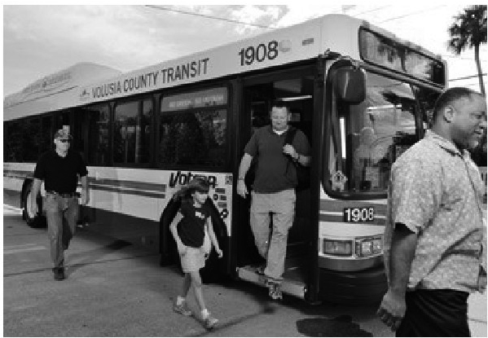
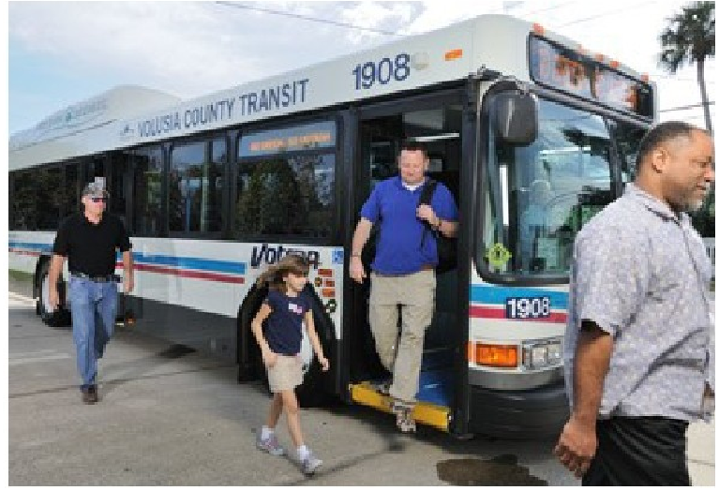
Image: Passengers exiting a Votran bus.

