Volusia County

Transit Development Plan

2019

Annual Update

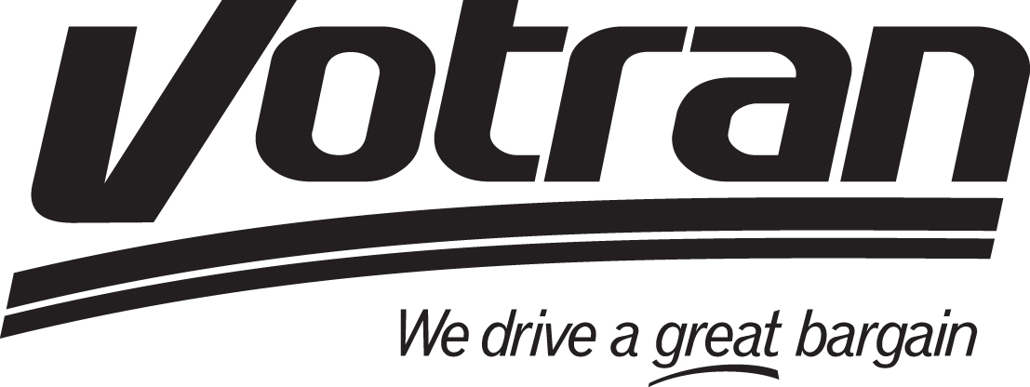

Updated August 20, 2019

Prepared by:

Frank Alvarez

Senior Planner

August 20, 2019

# 

Table of Contents

1.0 Introduction 4

2.0 Past Year Accomplishments 4

3.0 Public Involvement 18

4.0 Analysis of Discrepancies; Revision for the upcoming Year 18

5.0 Revision to the Implementation Plan 10th Year 18

6.0 Revised Financial Plan 19

7.0 Conclusion 22

APPENDIX I VOTRAN 2018 TDP FAREBOX REPORT 23

APPENDIX II VOTRAN VISIONING 25

TDP RULE CHECKLIST 26

# 

# 1.0 Introduction

Each public transportation agency that receives State Block Grant funding within the State of Florida is required by the Florida Department of Transportation (FDOT) to generate a Transit Development Plan (TDP). The plan covers a 10-year period and is intended to ensure that the provision of public transportation services is consistent with the travel needs and mobility goals of the community. The TDP serves as a guide in the future development of the transit system and encourages the consideration of strategic issues, mobility needs and prioritization of these needs in the form of a staged implementation plan.

Votran’s current major update of the TDP was adopted by Volusia County Council in October 2016. The following report is the Second annual update of the TDP. Annual updates must be in the form of a progress report on the 10‐year implementation program and must include:

* Past year’s accomplishments compared to the original implementation program;
* Analysis of any discrepancies between the plan and its implementation for the past year and

steps that will be taken to attain the original goals and objectives;

* Any revision to the implementation program for the coming year;
* Revised implementation program for the tenth year of the updated plan;
* A revised financial plan; and
* A revised list of projects or services needed to meet the goals and objectives.

# 2.0 Past Year Accomplishments

This section reviews Votran actions in 2018/2019. These accomplishments are organized according to the goals expressed in the adopted TDP. Some actions, such as marketing, relate to more than one goal and appear with the goal most directly corresponding to the TDP recommendations described fully in the following section. The performance information will utilize annual data wherever available. Therefore, the time frame for annual data for the reported year could be either the last completed fiscal year 2017/2018 or the most recent calendar year ending December 2019.

This TDP does not propose any deletions to the recommended actions.



Goal 1 - Objective 1.1 Monitor service

Votran compiled data for the preparation of an Annual Operating Report (AOR), the National Transit Database (NTD) reports, and performed a monthly review of performance that included both Fixed Route and Paratransit Operations. The Commission for the Transportation Disadvantaged Annual Operating report was prepared with assistance provided by River to Sea TPO staff and will be provided to the Transportation Disadvantaged Local Coordinating Board for review and approval in September 2018.

Votran operations staff monitored paratransit subcontractor performance at regular intervals throughout the year. Positive trends were documented and negative trends were immediately addressed. A new paratransit service contract was established in July 2018 that includes performance incentives and disincentives. Subcontractors will participate in quarterly tracking of on-time performance, completed trip manifests, complaints and commendations.

Monitoring service is the method by which Votran management staff prepared service improvement recommendations for consideration and adoption by Volusia County Council. Each year the Volusia County Council participates in a review process during budget workshops conducted during regularly scheduled and publicly noticed meetings held throughout the year. The public meeting allows county staff, elected officials and the public to share the understanding of Votran’s service levels. The most recent workshop was held February 19, 2019. A copy of this presentation is available at <https://www.volusia.org/government/county-council/county-council-meetings/agenda.stml>.

The following tables represent FY 2018 annual information reviewed by Votran management staff.



Goal 1 - Objective 1.2 Improve service levels

In the previous fiscal year (FY 2018), $255,468 in funding was added to the Votran operating budget to add service on State Road 44 in New Smyrna Beach. The Route 44 runs from the Julia & Sams Connection Point in downtown to the Walmart near I-95, across the South Causeway to the beachside and then back downtown. The route runs Monday – Saturday from about 6:45 am to 6:45 pm, on 60 minute headways.

In fiscal year 2019, $338,870 in funding was included in the Volusia County Five Year Forecast to add service on Howland Blvd in Deltona. Route 25 operates primarily along the Howland Blvd corridor between the Dupont Lakes Shopping Center near Elckam Blvd to the Epic Theatre and Halifax Hospital near I-4. The route runs Monday – Saturday from about 7:30am to 7:30pm every 90 minutes. Service began February 25, 2019.

Another active discussion of service development was the New Smyrna Beach business group’s effort to launch a trolley service. The group has been working with the New Smyrna Beach Economic Development Department to organize a proposal to support the need for relieving traffic and parking issues in the popular Flagler Avenue commercial district. Votran staff members have supported this group in the development of options. To date, this project has resulted in a grant application for FDOT service development funds. However, the City of New Smyrna voted to turn down the FDOT grant. Due to lack of support, the trolley service has been postponed.

Across the county there have been needs expressed to expand services beyond the existing route structure, as described below in Objective 1.4, including: the retail area of Tanger Outlets; and the Daytona State College DeLand Campus.

Goal 1 - Objective 1.3 Votran Fleet

Votran’s fixed route buses are classified as heavy duty vehicles with a life cycle of 12 years. Based on our current duty cycle, annual miles driven, and other factors, the average age of a Votran heavy-duty vehicle in FY 18 was calculated at 7.18 years. Votran submitted federal grants for new vehicles that will be replacing the older vehicles in the fleet.

Goal 1 - Objective 1.4 Connectivity throughout the region

Votran’s Customer Service/Planning Department staff manages on board surveys as part of every major Transit Development Plan. The most recent survey was completed in the summer of 2016. In addition, on-board surveys are taken between TDPs when needed.

Unmet needs were reviewed at the Volusia County Council 2018 budget workshop including:

*Estimated costs for service Monday – Saturday 7:00 AM – 7:00 PM (unless otherwise noted)*

|  |  |  |  |  |
| --- | --- | --- | --- | --- |
|  | *Fixed Route operating* | *Estimated Paratransit* | *Capital Cost* | *Estimated Total* |
| *Night Service in West Volusia – Routes 20 & 60 (until 10PM) – Service expansion* | *$ 281,700* | *$ 84,510* | *-* | *$ 366,210* |
| *Sunday Service in West Volusia – Routes 20 & 60 (until 7PM) – Service expansion* | *$ 187,200* | *$ 56,160* | *-* | *$ 243,360* |
| *Daytona State College – DeLand, Volusia County Fairgrounds, Victoria Park* | *$ 281,700* | *$ 48,775* | *$ 483,435* | *$ 813,910* |
|  |  |  |  |  |
| *North American Development Group – I-95 / LPGA area for growing retail, and residential development* | *$ 347,925* | *$ 40,150* | *$ 483,435* | *$ 871,510* |
| *Total operating and capital expenses for all options* | *$1,098,525* | *$229,595* | *$996,870* | *$2,294,990* |

Farebox recovery is the fare revenue divided by total operating expenses. It measures the percentage of direct operating costs that are recovered through the fares paid by the customers. See the farebox report in Appendix II. The farebox recovery ratio for Votran, the proportion of operating revenue generated by passengers, was 16.2 percent in FY 2018.

Votran continues to utilize graphic bus advertising on both fixed route and paratransit vehicles. This practice succeeds in enhancing the look of the vehicles as well as generating revenue for the agency. Vector Media submitted the winning proposal and a five year contract became effective October 1, 2019. FY 2018 advertising revenue was $365,012.

As lack of funding remains the challenge to implementation of expanded service, Votran has continued to track key destinations that are priorities for service development beyond the existing fixed route corridors. Destinations below remain priorities for the community, with many of them identified during the 2016 development of the major update of the TDP:

* Victoria Park Medical Offices
* DeLand Amtrak Station
* Daytona State College in DeLand
* East/west connector to SunRail
* Daytona Beach industry and retail development at LPGA and I-95

Votran staff will continue to pursue funding opportunities to expand service within the County. In the spring of 2017, Tindale Oliver consultants produced a Visioning map that overlays the new development areas with the Votran routing (see Appendix II).

Goal 1 - Objective 1.5 Ensure capable staff

A great challenge for the Votran management team is one that is shared by industry partners throughout Florida: to retain and recruit the brightest transit professionals during a robust economy with a competitive job market. Votran Human Resources staff achievements during FY 18/19 included:

* Attended Equal Employment Opportunity Commission (EEOC) conference, including legal updates and guidance on National Origin Discrimination
* Created relationships with local career and job placement centers, including Career Source and those agencies focusing on veterans and their spouses
* Reviewed and updated exit interview process to reduce turnover and improve the work environment for future employees
* Attended monthly local Society for Human Resource Management (SHRM) meetings
* Conducted outreach at local job fairs

Votran managers worked with: Rural Transit Assistance Program (RTAP); the University of South Florida’s Center for Urban Transportation Research (CUTR); and Florida Department of Transportation (FDOT) on training opportunities for staff in the areas of operations, maintenance, planning, and human resources. Staff training throughout the current year included:

* Votran's staff participated in the Florida Public Transportation Association (FPTA) Annual Conference, the Commission for the Transportation Disadvantaged (CTD) annual conference, and with the FPTA/CUTR mid-year professional development workshop.
* Votran's Maintenance Director participated with the FDOT/CUTR Maintenance Consortium Group,
* Votran's Operations Manager, Human Resources Manager, and the Safety Officer attended a meeting with the FTSON-Florida Transit Safety and Operations Network.
* The Human Resources Manager completed certification of FDOT Drug and Alcohol Program Manager.
* Votran’s Paratransit Operations Supervisor participated in the second annual FPTA Public Transportation Leadership Development program
* Mandatory Safety and Compliance training events are conducted annually. Training in Spring 2019 has focused on: ADA service requirements and updates; safety and security issues; Right-To-Know/Hazardous Materials consistent with the Globally Harmonized System (GHS); Defensive Driving/Safety; Injury and Illness Prevention Training; Bloodborne Pathogens; Substance Abuse Policy; Harassment; and Customer Service. Special emphasis was devoted to pre-trip safety inspections, with additional time focused on our new web based customer service tools.

In 2018, Votran’s Customer Service Manager, Edie Biro received the 2018 Sheila Winitzer Shining Star Award and Dispatcher Susan Smeltzer received the 2018 Dispatcher/Scheduler of the Year Award from CTD.

In September of 2019, Rick Kazawitch was named the Maintenance Director of the year by Metro Magazine.

Votran is establishing an agreement for providing a new training initiative with FDOT. This agreement provides funding to support the Department's Bus Maintenance Technicians Training Program.

In 2018, Votran hired a maintenance trainer for the purpose of meeting local training needs. The trainer will work on local training demands and will be provided support by the FDOT sponsored Transit Maintenance, and Analysis Resource Center (TMAARC) housed at the University of South Florida.



Goal 2 - Objective 2.1 Safety

Votran’s top priority is safety and security. The general manager has designated the assistant general manager of operations and maintenance, the director of maintenance, operations manager, and the director of safety and training as safety coordinators. Votran safety coordinators are directed and empowered to devise, implement, and administer a comprehensive and coordinated System Safety Program Plan (SSPP) with specific activities to prevent, control, and resolve unsafe conditions which may occur during both design and operational stages. This authority includes the right to stop any operation which the safety coordinators determine is not safe. It is the duty of every Votran team member to cooperate with the safety coordinators and provide them with any requested information that may help in any investigation or inspection they may undertake. (Management Statement of the SSPP). Votran is working to implement the Safety Management System before July of 2020.

In 2018, Votran was recognized for the following achievements:

* FPTA Tier 2 Certificate of Merit for Safety Certificate of Merit – Bus Safety and Excellence Awards
* Hosting the FPTA Annual Conference & Expo
* CTD Safety Award

Votran continues to provide training for the paratransit sub-contractor’s management staff as well as defensive driving courses for their bus operators as required under the contract. The most recent Annual Safety Certification is dated January 31, 2019.

Votran also provides opportunities for the contracted paratransit bus operators to attend customer service and passenger sensitivity training when it is provided for Votran employees.  Votran provides our vendors who contract for the provision of paratransit services ongoing monthly training on US DOT / Federal Transit Administration Substance Abuse Training / Drug Free Workplace Training, Florida Administrative Code 14.90, State of Florida Commission for the Transportation Disadvantaged Commission requirements as outlined in Chapter 427, and Administrative Rule 41.2, and the American with Disabilities Act training. Contracted providers are also invited to send employees to our new bus operator training classes that cover defensive driving, wheelchair securement, escorting passengers, wearing photograph identification, and more.

Safety is the objective for improvements and maintenance throughout the agency infrastructure. Security cameras are installed on all revenue vehicles, as well as at the Transfer Plaza, the Intermodal Facility (Ocean Center), and the Operations Center.

To encourage our customers to be safe, we have begun a safety campaign onboard our buses and facilities, which includes signage and in vehicle announcements.

All new bus stops are installed according to the current ADA design guidelines. In the previous fiscal year, Votran undertook a two-phase project to improve bus stops in the unincorporated area. The first phase completed the installation of ADA accessible boarding and alighting pads at 96 existing bus stops. The second phase, with 34 remaining bus stops is still ongoing with estimated completion during FY 19/20.

Goal 2 – Objective 2.2 Votran branding

Votran was successful in obtaining support from the FDOT for the purpose of marketing the Votran rider tools to the public. This project is more fully described in Objective 2.4 below.

*Community Outreach*

Votran participated in the current year as a member of several planning/advisory committees including the Transportation Disadvantaged Local Coordinating Board (TDLCB), Technical Coordinating Committee (TCC) and Citizens Advisory Committee (CAC), Bicycle Pedestrian Advisory Committee (BPAC)

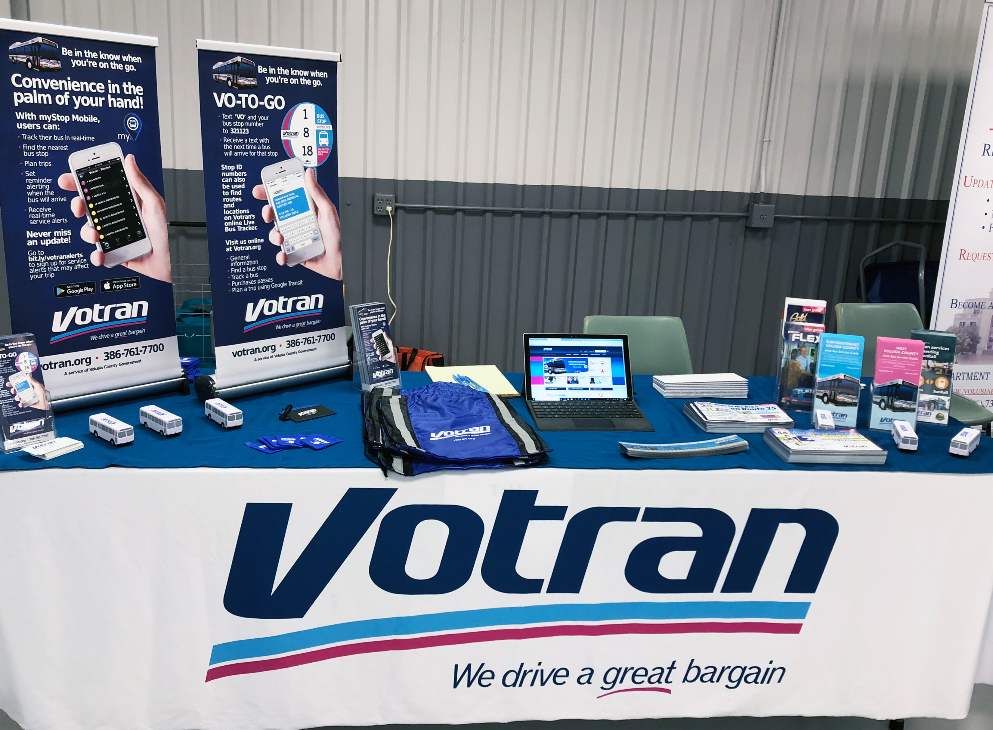

Votran interacts with the community throughout the year to make presentations to special populations. These events help Votran inform, educate and receive feedback from people representing a variety of interests throughout the County. In FY 2018/19, presentations and outreach included:

* Senior resident community meetings
* Vehicle days at Public Schools throughout the county
* HUD Family Self Sufficiency Daytona Beach Housing Authority Sub committee
* Daytona Beach Convention and Visitors Bureau
* Halifax Area Advertising Authority Board
* Shriners International 2018 Imperial Session
* Daytona State College Disability Awareness Day
* Rehabilitation Center for the Blind
* Halifax Council of the Blind
* Rotary Club of Daytona Beach
* Seabreeze-Daytona Beach Kiwanis Club
* The How to Festival
* International Speedway Boulevard Coalition
* Volusia Magazine public television broadcasts periodically with the Votran General Manager
* Volusia County Emergency Operations Center
* Methodist Children’s Home
* Hurricane Expo
* Mobility Week
* Volusia County Transportation Disadvantaged Local Coordinating Board
* Transportation Planning Organization
* Bicycle and Pedestrian Board
* Resident’s Council at AHEP Apartment Complex
* Neighborhood Watch, Daytona Beach 5th District
* One Voice Volusia

Marketing

Over two years, Votran has increased frequency on four routes, and since then we have worked to raise awareness of these service improvements by creating marketing items such as rack cards, bus wraps, and advertisement in newspapers and on Facebook as well as attending community events.

Within the next year, updates throughout Votran.org will be made to enhance communication to users and to update pages as needed.

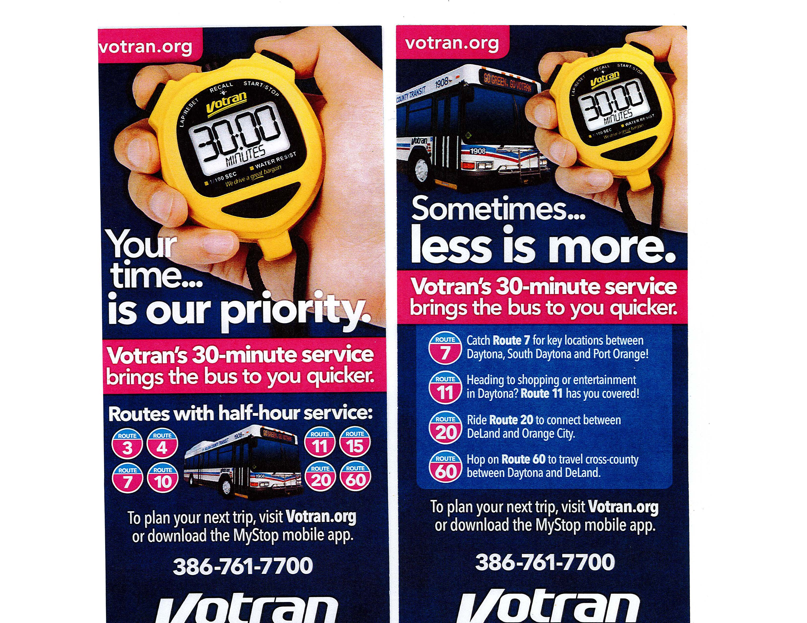

In addition to increasing frequency, Votran introduced two new routes. Route 44 began service in June 2018. It serves the State Road 44 corridor from downtown New Smyrna Beach to Walmart near I-95 and the beachside before returning to the downtown superstop at Julia and Sams. A campaign to inform the community about the new service was created and successfully deployed which included the Route slogan "From the shore to the store its Route 44". Votran won second place for the Route 44 marketing campaign by the FPTA.

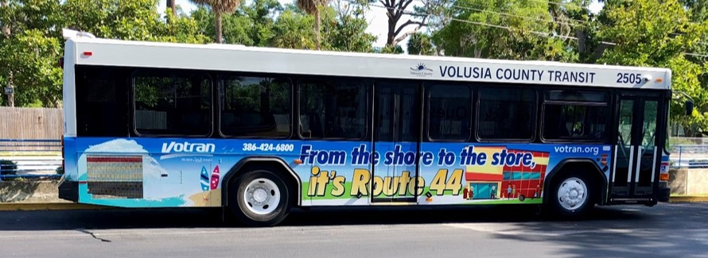

Route 25 began service in February 2019, serving Howland Blvd in northern Deltona between Dupont Lakes Shopping Center and Halifax Health Hospital. As with previous new routes, a campaign was deployed to inform the community of the route which included the route slogan " Ride to the Big 5 on Route 25" referencing the five significant locations along that route. Similar to Route 44, a bus wrap advertising Route 25 has also been added to the fleet.

Goal 2 – Objective 2.3 Fleet Maintenance

Votran maintains a written vehicle maintenance plan for federally funded rolling stock. Votran’s Maintenance Department cleans each vehicle every day. All vehicles purchased for revenue service are fully ADA accessible. The plan and preventative maintenance checklists are consistent with the current operating fleet.

Votran’s maintenance plan and checklists exceed those recommended by the manufacturer. The Votran maintenance team participates in an industry consortium to provide, obtain and share information. Staff stays in continual contact with FDOT on industry issues and staff stays in continual contact with manufacturers for updates and support.

Votran’s schedule for vehicle preventative maintenance inspections has intervals of 6,000, 18,000, and 36,000 miles. These inspection intervals are outlined in Votran’s maintenance plan. The maintenance department consistently meets these intervals unless unusual circumstances prevent this from occurring.

Votran’s Asset Management Plan was adopted in March 2016 and reviewed with FDOT during the Triennial Review with Votran in July 2017. Votran’s maintenance plan outlines on-time performance goals of 90% of required interval for preventive vehicle maintenance. In the most recently completed calendar year, the average preventative maintenance vehicle inspections performed on time was 97.11% for fixed route vehicles and 99.56% for paratransit vehicles. For each monthly period, the maintenance department generally exceeds the 90% goal unless unusual circumstances prevent this from occurring.

Objective 2.4 Customer access to transit information

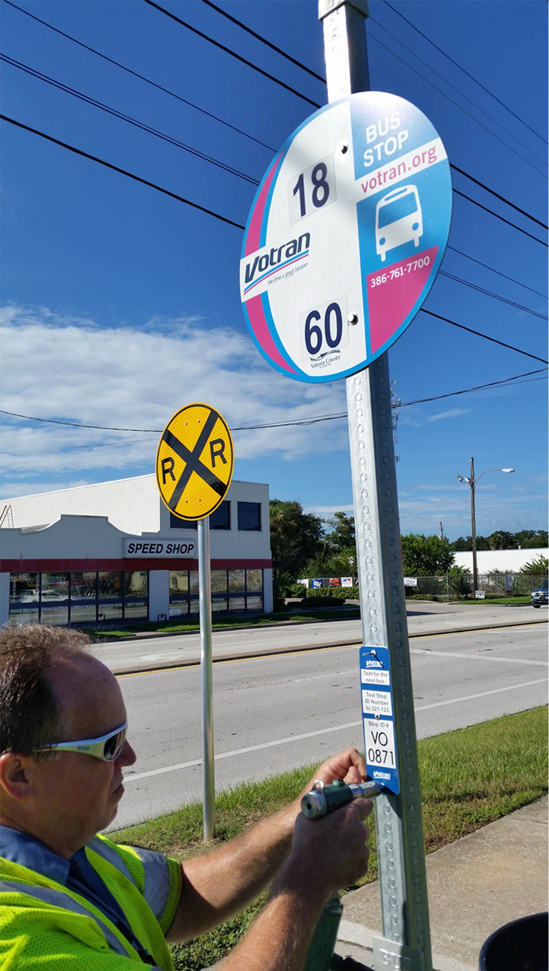

Easy access to Votran’s transit customer information improves the ability of transit riders to use scheduled bus services on fixed routes. The greatest challenge for riders to use a bus system is to find out how to get to a destination and how long the trip will take. The rider technology tools improve the rider experience in planning the trip and even during their trip in the mobile environment to obtain bus departure information or other navigation assistance.

The complexity of the technology marketing subject has been supported by collateral materials in a wide array of marketing and outreach efforts including:

* Media notices: A reminder tag line has been added at the end of every news release “Votran riders are encouraged to plan trips in advance. Riders may learn more by visiting votran.org. The website provides up-to-date alerts and real-time bus tracking. It also offers downloadable information for the MyStop mobile app for real-time bus information anywhere.”
* Electronic messages: News releases and periodic service reminders are sent to email subscribers, currently there are more than 640 active members signed up for this service. Collaborations with other community based email subscriber service has been effective in reaching the business community via the Greater Daytona Beach Chamber of Commerce and “One Voice Volusia”, a coalition of about 100 agencies connecting non-profit, governmental and community-based organizations along with local businesses to promote system and community improvements.

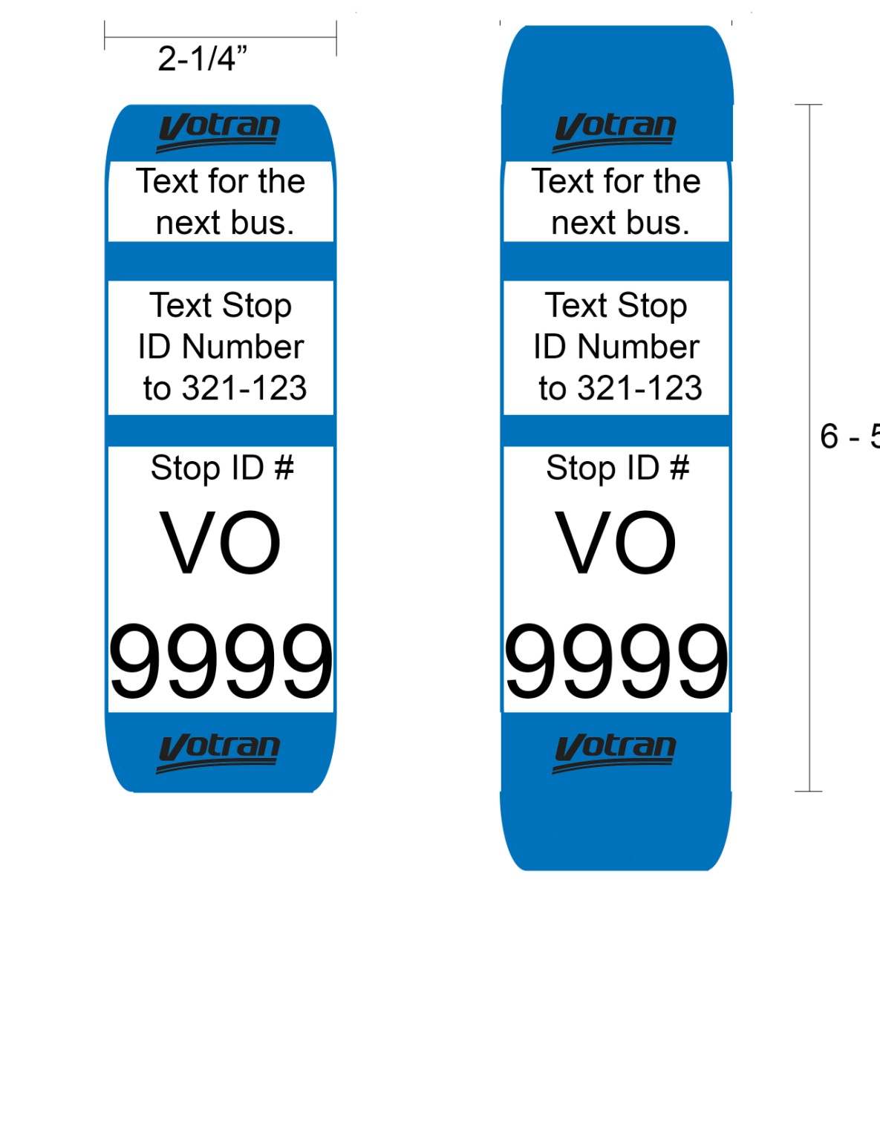

* At the Transfer Plaza and both Intermodal Facilities in Daytona Beach and in DeLand, there are LED signs that display bus arrival and departure times, as well as service alerts and detours.
* Votran staff members regularly make presentations, among them: by invitation at a community organization site; on the Votran site to visiting service groups; or public meetings including the River to Sea Transportation Planning Organization committees.

The objective in marketing these transit products is to help riders reduce the wait time needed outdoors at a bus stop. Admittedly waiting for a bus can be tiresome in the Florida weather, and can become frustrating when unexpected delays happen. The Votran service area is home to many international events such as the Daytona 500 and other racing events, Bike Week, Biketoberfest, and the Country 500 music festival among other emerging seasonal festivals and celebrations. Getting riders to use the above rider tools has been the objective to better serve the community.

Since implementing these tools, web site visits to votran.org was 15,866 in March 2018, up from 3,100 in March 2014. Vo-to-Go messages has grown to approximately 530 per weekday. To date over 22,814 unique riders have used the Vo-to-Go rider text service. Votran has helped thousands of riders by improving access to transit information they need for day-to-day success in getting to their destinations.

Votran has acquired Trapeze Ripple (Interactive Voice Response – IVR) software to automate Votran Gold customer trip reminders by automated outbound calls and customer inbound calling. In March 2018, an introductory letter was mailed to over 1,100 Votran Gold customers announcing that this service is now available. The functions available to Votran Gold customers are: automated vehicle arrival alerts when their vehicle is within 15 minutes of their location; automated next day trip reminders that also allow customers to confirm their intent to travel or to cancel if they no longer plan to make the trip; outbound mass messages about emergency alerts; customers may choose to receive trip reminders and vehicle arrival alerts by text message. The Ripple system has been implemented with the name “Vo-Call”.

Goal 2 – Objective 2.5 Increase service frequency

Votran’s Operations Staff reviews all time points to determine an average time the fixed route bus reached each point. The bus schedule/time point adjustments reflected in the published schedule were updated twice in the current fiscal year. Staff will continue to monitor on time performance for routes and will make adjustments as needed.

Goal 2 – Objective 2.6 Fare collection methods

Votran is considered one of the regional partners in the Lynx mobile pay project. As mobile pay has been deployed more widely throughout the nation there are a number of technology vendors to be considered. The system will allow users to pay using smart phones which can be visually verified by the driver or through this use of a reader on the bus. Votran staff will be exploring options for mobile pay in the coming year.



Goal 3 – Objective 3.1 Intelligent Transportation System (ITS) improvements

Votran adopted its Transit Asset Management Plan in March 2016 that incorporated planned replacement and maintenance of equipment and software. Votran’s Technology Officer coordinated vendor activities during the current fiscal year that included:

* Ripple software module in Trapeze for providing paratransit customer information was implemented. It was implemented in March 2018 and has been introduced to Votran Gold customers as “Vo-call”.
* Bus Stop Manager Software module in Trapeze for managing bus stop inventory was fully deployed in May 2018.

Goal 3 - Objective 3.2 assess all major capital purchases

Votran management team members met quarterly to assess performance reports and discuss progress on capital needs and procurement activities. During FY 17/18, Votran managers reviewed opportunities for capital improvements such as revenue vehicle fleet status, regional training center equipment, communication technology, and phone system needs. During FY 18/19, new fixed-route and paratransit vehicles were purchased to help improve the efficiency of an aging fleet.



Goal 4 – Objective 4.1 Increase local knowledge of transit impact

Votran has continued participation on the River to Sea TPO’s Transportation Disadvantaged Local Coordinating Board (TDLCB), the Technical Coordinating Committee (TCC), the Citizen Advisory Committee (CAC) and the Bicycle and Pedestrian Advisory Committee (BPAC). In addition, Votran staff members have provided input regarding site plan review for Volusia County and various city road projects being planned by FDOT. Votran also participated as a member of the Technical Advisory Committee for SunRail and participated in the Central Florida MPO Alliance. During the 2017/18 fiscal year, Votran has maintained participation in the corridor planning projects focused on the International Speedway and the Volusia County Cross County Connector projects sponsored by FDOT, which was published in February 2017. The TPO is an integral part of the public involvement process.

Votran will continue to coordinate with reThink, FDOT and SunRail in community outreach efforts to promote the commuter services.

Goal 4 - Objective 4.2 Educate

Votran staff made multiple presentations throughout the year, as described in Objective 2.2 above. In addition, Votran provides travel training and assessment services. Votran is working to create a larger travel training program offered multiple times a year throughout the county to benefit those that wish to learn about public transit. Votran staff prepared news releases to provide service notifications for special event adjustments. These news releases were also sent electronically to Votran’s email notification subscribers.

Currently, the Transportation Disadvantaged Local Coordinating Board meets every two months at the Votran Operations Center. Beginning January 2020, the TDLCB will be meeting quarterly. This is advertised as a TPO public meeting. In addition, in compliance with the CTD, a public hearing was held November 14, 2018 at the Votran Administration Building following the TDLCB meeting. All TPO meeting notices, agenda and minutes are published at <https://www.r2ctpo.org/board-committees/tpo-board/> .

Votran has worked with the County and municipalities during the budget cycle for FY 18/19 to review transit needs and has communicated with those municipalities where development has occurred beyond the service area. This communication will continue as the economy continues to improve in the coming year.

Annual Progress Report

The annual progress report update is provided to encourage Votran to evaluate its progress toward achieving each goal. An explanation as to why some goals are unmet can be found above in the subsection relating to that goal.

|  |  |  |  |  |  |  |  |  |  |  |
| --- | --- | --- | --- | --- | --- | --- | --- | --- | --- | --- |
| Fiscal Year | 2017 | | 2018 | | 2019 | | 2020 | | 2021 | |
| Goal Status | In Progress | Achieved | In Progress | Achieved | In Progress | Achieved | In Progress | Achieved | In Progress | Achieved |
| Goal 1 |  |  |  |  |  |  |  |  |  |  |
| Goal 2 |  |  |  |  |  |  |  |  |  |  |
| Goal 3 |  |  |  |  |  |  |  |  |  |  |
| Goal 4 |  |  |  |  |  |  |  |  |  |  |
| Fiscal Year | 2022 | | 2023 | | 2024 | | 2025 | | 2026 | |
| Goal Status | In Progress | Achieved | In Progress | Achieved | In Progress | Achieved | In Progress | Achieved | In Progress | Achieved |
| Goal 1 |  |  |  |  |  |  |  |  |  |  |
| Goal 2 |  |  |  |  |  |  |  |  |  |  |
| Goal 3 |  |  |  |  |  |  |  |  |  |  |
| Goal 4 |  |  |  |  |  |  |  |  |  |  |

# 

# 3.0 Public Involvement

Within the last three years, Votran has increased the number of public involvement and outreach activities. Public meetings were held on October 24th and 26th of 2017 and again on November 15th and 20th of 2018. These meetings were regarding proposed route adjustments and the addition of two new routes. The Volusia County Council must approve any major service changes. In addition to the formal meetings, Votran also attends many informal public activities to inform the public of the services provided by Votran and to allow the public to comment and make suggestions on our service. These activities include FDOT Mobility Week, information table at local libraries, presentations at churches. Spanish speaking staff was available at these events.

# 4.0 Analysis of Discrepancies; Revision for the upcoming Year

There were no major discrepancies for the FY 2018/19 operating year. The major projects for the upcoming year, listed in the TDP, are geared towards improving transit access through continued support of frequency and new service as described above.

While the Volusia County economy has improved, competing priorities for County operating funds and a lack of a dedicated funding source continues to limit expansion of transit service. Discrepancies in the 10-year implementation plan should be expected as enhancement initiatives remain a priority without a funding source and will stay organized in the same sequence of years. Therefore, the updated implementation plan of future years will reflect Votran progress with the unfunded projects. As indicated in this report, Votran steps for the coming FY 2019/20 year will be to continue implementation of the funded improvements.

# 5.0 Revision to the Implementation Plan 10th Year

The operating improvements associated with expansion of service have proven to be limited over the past five years and, as described in Section 3.0, may continue to be constrained for the 10th year. The additional 10th year financial plan was formulated with the updated status of the service improvements expected in the coming year. Per the manual, FDOT Guidance for Producing a Transit Development Plan, “It is recognized that the 10th year action plan will not have the benefit of the comprehensive study carried out in the original TDP development. Thus, this 10th year plan…may well be modified at the next major TDP update.”

# 

# 6.0 Revised Financial Plan

The updated financial plan represents the updated plan spreadsheet using the expected FY 2019 actual expenditures to project estimated expected in September 2019 for planned and existing service. We have shown no new operating initiatives for the 10th year. Votran is planning to develop the scope of services for planning the next major TDP update to focus on transit infrastructure and community needs. For this update, we have not added to the TDP list of projects needed to meet the goals and objectives.

Ten-Year TDP Financial Plan



# 7.0 Conclusion

Votran is concluding the third year of implementation beyond the base-year Transit Development Plan (TDP) adopted October 2016. Although several of the recommendations have yet to be completed, Votran is not expecting any implementations in the coming year. The robust economy has improved development across Volusia County, and Votran will continue to seek funding opportunities that will allow further service development.

# APPENDIX I VOTRAN 2018 TDP FAREBOX REPORT

VOTRAN – FIXED-ROUTE SYSTEM, VOLUSIA COUNTY, FLORIDA

CURRENT FAREBOX RECOVERY RATIO

The farebox recovery ratio for Votran, the public transportation provider for Volusia County,

was 16.2% percent in FY 2018. This percentage was calculated based on the following methodology. Fixed route farebox $ 2,531,562 / Fixed route operating expense $15,555,129 = 16.2%.

FARE STUDIES AND CHANGES

A fare increase was approved by the County Council that became effective February 16, 2014. This fare increase brought the base fare from $1.25 to $1.50, representing a 20 percent increase. The second and last phase of the fare increase was implemented effective February 2, 2015. This raised the fixed route base fare from $1.50 to $1.75. Votran publishes the fare structure in the printed consolidated route map and schedules, and it is posted on the web site <http://www.votran.org/take-a-trip/bus-fares-passes.stml>. Votran continues to monitor fare revenue and annually reviews revenue sources with Volusia County Council at each budget workshop.

FY2017

|  |  |  |  |  |
| --- | --- | --- | --- | --- |
| Company Name | Operating Expense Per Passenger Trip | Operating Expense Per Passenger Mile | Farebox Recovery (%) | Average Fare |
| Votran Volusia County, FL | $4.62 | $1.10 | 16.88 | $0.78 |
| PCPT Port Richey, FL | $7.43 | $1.07 | 12.1 | $0.90 |
| LeeTran Fort Myers, FL | $5.26 | $1.00 | 16.65 | $0.88 |
| CAT Savannah, GA | $5.73 | $2.22 | 18.94 | $1.08 |
| SCAT Sarasota, FL | $7.68 | $1.47 | 8.72 | $0.67 |
| CATS Baton Rouge, LA | $6.46 | $1.64 | 7.65 | $0.49 |
| SCAT Cocoa, FL | $3.32 | $0.57 | 11.83 | $0.39 |

Source: http://ftis.org

STRATEGIES THAT WILL AFFECT THE FAREBOX RECOVERY RATIO

The FY 2017-2026 TDP Major Update identifies several strategies that will be used to maintain or increase the farebox recovery ratio, including the following:

• Increase ridership through more strategic marketing activities aimed at attracting choice riders;

• Ensure that transit serves major corridors, employers, and activity centers (including colleges/universities);

• Continue to evaluate services and make service modification to improve lower performing routes or to remove these routes from the system;

• Review the applicability of premium service on major corridors to provide a competitive modal option over automobile use;

• Provide local employers with incentives for transit use;

• Improve the existing schedule to attract new riders;

• Monitor key performance measures for individual fixed routes;

• Assess the existing fare periodically to guarantee fare revenue levels are maintained proportionate to expenses;

• Increase ridership by continuing to transition transportation disadvantaged service customers to the fixed-route system;

• Improve frequencies on the fixed-route system to attract new riders;

• Ensure that bus passes can be purchased at locations that are convenient to the riders;

• Set a goal to increase farebox recovery and have staff commit to achieving the goal through a suggestion program that encourages more efficient ways to provide service;

• Inform customers on the importance of paying the correct fare for each trip through a marketing approach. This customer information effort should be combined with an operator education initiative on the importance of reducing the instances of short-fare trips; and,

• Review the applicability of reloadable fare cards and mobile fare payment or other fare options to increase sales.

• Review the applicability of smart cards and other fare options to increase sales.

# APPENDIX II VOTRAN VISIONING

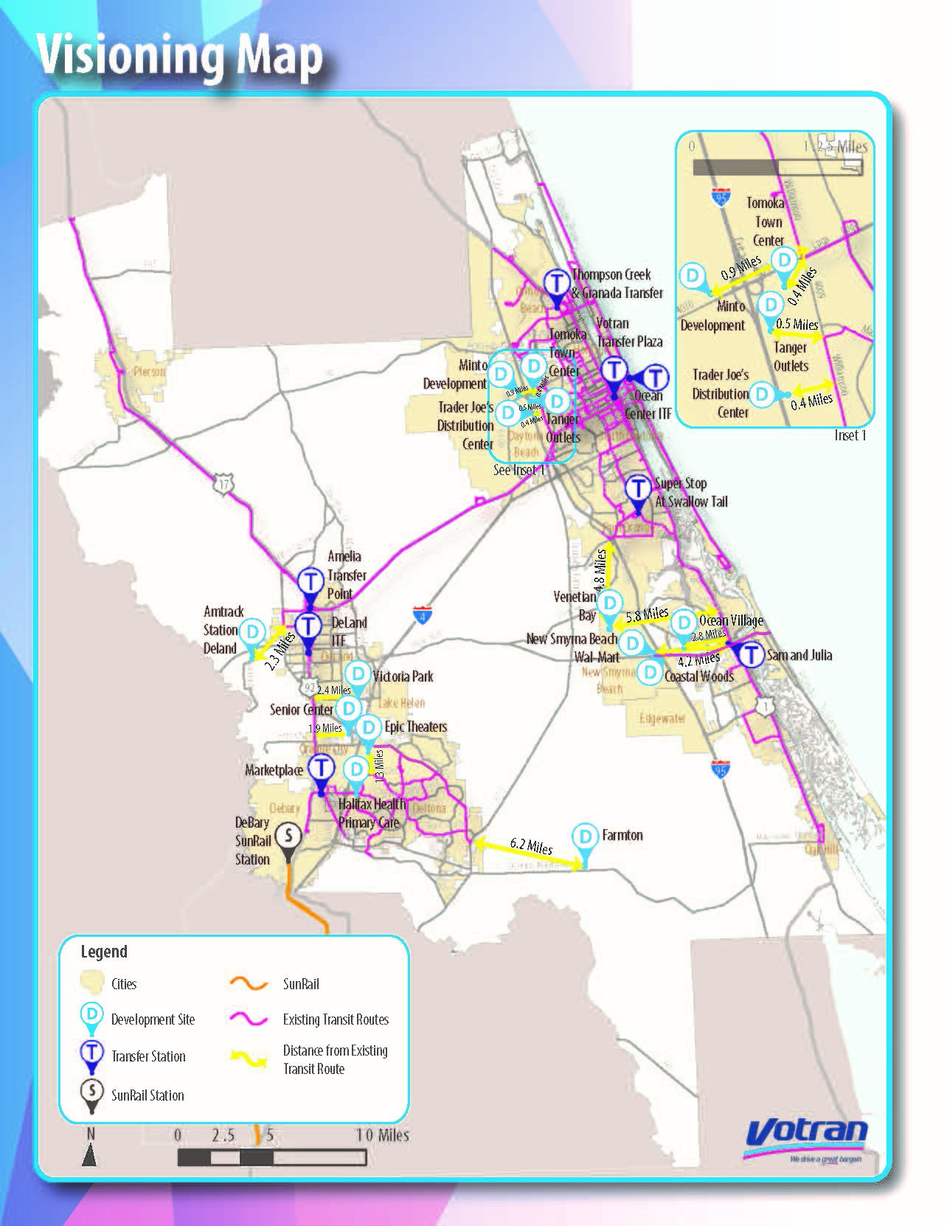

# TDP RULE CHECKLIST

Annual Updates

COMPLIANCE WITH NEW TRANSIT DEVELOPMENT PLAN (TDP) RULE

FLORIDA DEPARTMENT OF TRANSPORTATION

RULE: 14-73.001

|  |  |  |  |  |  |
| --- | --- | --- | --- | --- | --- |
| TDP Rule Reference Item # | TDP Annual Update | Yes | No | Location in TDP | Comments |
| 4. | Is the annual update in the form of a progress report on the ten-year implementation plan? | ✓ |  | Page 4 to Page 15 | Each goal contains a status update |
| (a) | Does the progress report include the past year’s accomplishments compared to the original implementation program? | ✓ |  | Page 4 to Page 15 | Each goal is followed by accomplishments stated in measures and narrative for objectives in the original implementation program |
| (b) | Does the progress report include an analysis of any discrepancies between the TDP and its implementation for the past year? | ✓ |  | Page 16 | Section 3.0 summarizes the finding that there are no major discrepancies to report |
|  | In relation to 4(b) above, does the progress report include steps the Provider will take to attain the original goals? | ✓ |  | Page 16 | Section 3.0 identifies the priorities to attain the original goals |
|  | In relation to 4(b) above, does the progress report include steps the Provider will take to attain the original objectives? | ✓ |  | Pages 16 | Section 3.0 provides the statement of commitment to the original goals and objectives. |
| (c) | Does the progress report include any revisions to the implementation plan for the coming year? | ✓ |  | Pages 16 to 18 | Unfunded projects have been budgeted to begin in FY 18. |
| (d) | Does the progress report include the revised implementation program for the tenth year? | ✓ |  | Pages 16 to 18 | The tenth year is shown in the financial plan. |
| (e) | Does the progress report include added recommendations for the new tenth year of the updated plan? |  | ✓ |  |  |
| (f) | Does the progress report include a revised financial plan? | ✓ |  | Page 18 | The financial plan is updated |
| (g) | 1(g). Does the progress report include a revised list of projects or services needed to meet the goals and objectives? |  | ✓ |  |  |
|  | 2(g). Does the progress report include a list of projects, pertinent to 1(g). above, for which the Provider did not identify funding? |  | ✓ |  |  |